All HTML elements can be considered as boxes.

In CSS, the term "box model" is used when talking about design and layout.

The CSS box model is essentially a box that wraps around every HTML element. It consists of: content, padding, borders and margins. The image below illustrates the box model:

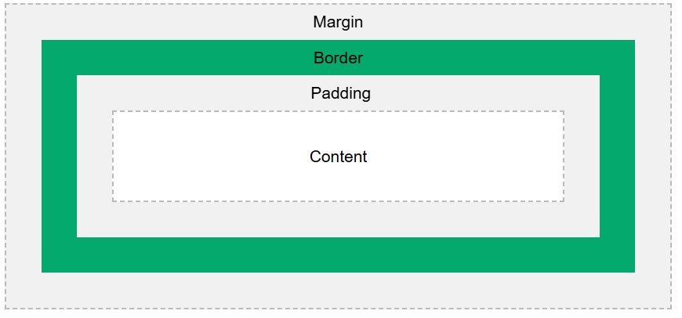

Explanation of the different parts:

* **Content** - The content of the box, where text and images appear
* **Padding** - Clears an area around the content. The padding is transparent
* **Border** - A border that goes around the padding and content
* **Margin** - Clears an area outside the border. The margin is transparent

**Example 1 :**

**<html>**

**<head>**

**<style>**

**div {**

**background-color: lightgrey;**

**width: 300px;**

**border: 15px solid green;**

**padding: 50px;**

**margin: 20px;**

**}**

**</style>**

**</head>**

**<body>**

**<h2>Demonstrating the Box Model</h2>**

**<p>The CSS box model is essentially a box that wraps around every HTML element. It consists of: borders, padding, margins, and the actual content.</p>**

**<div>This text is the content of the box. We have added a 50px padding, 20px margin and a 15px green border. Ut enim ad minim veniam, quis nostrud exercitation ullamco laboris nisi ut aliquip ex ea commodo consequat. Duis aute irure dolor in reprehenderit in voluptate velit esse cillum dolore eu fugiat nulla pariatur. Excepteur sint occaecat cupidatat non proident, sunt in culpa qui officia deserunt mollit anim id est laborum.</div>**

**</body>**

**</html>**

**Example 2 :**

**<html>**

**<head>**

**<style>**

**div {**

**width: 320px;**

**height: 50px;**

**padding: 10px;**

**border: 5px solid gray;**

**margin: 0;**

**}**

**</style>**

**</head>**

**<body>**

**<h2>Calculate the total width:</h2>**

**<img src="klematis4_big.jpg" width="350" height="263" alt="Klematis">**

**<div>The picture above is 350px wide. The total width of this element is also 350px. The total height of this element is 80px.</div>**

**</body>**

**</html>**